

CECS 347 Fall 2018 Final Project

Autonomous Wall Following Robot Car

By

Brandon Da Silva & Alina Suon

12 / 19 / 18

Developing an autonomous wall following robot car that sense walls to navigate through a series of course avoiding interactions with inanimate objects.

**Introduction**

In creating an autonomous wall following robot car we will incorporate all previous knowledge and previous projects. An autonomous robot car does not require a remote control instead is able to function on its own. It will make turns according to the sensor and thus be able to adjust its speed accordingly. Either infrared sensor or ultrasonic sensor can be implemented. For our project, we utilized two ultrasonic sensor, it will have an analog input.

There are two aspects to this project. First is implementing the autonomous car to navigate through a straight course between two walls. Second task is enhancing our car to be able to navigate through a route that has both a right and left turn. The car will start to navigate to the other side of the course, and as soon as it reaches either end, it should stop.

**Operation**

The car is to move in the middle of the course while navigating through it to the other ends. It will start off course and realign itself throughout. The car should move no closer than 10 cm to either side of the wall and once in motion should not stop until it reaches the end of the route. It’s first route is a straight track, requiring the car to move from one end to the other approximately 60 cm - 80 cm long. Two sensors are implemented reading the sensor left and right. As soon as one side distance is shorter than the other side, then the longer side will turn to the opposing by changing its speed. Two approach can be made: Speed up one of the wheel or slow down the other wheel. In deciding to slow down one wheel, it will require a port that sets up the initial start up speed. It will be tested at three starting location: 15 cm to the left and right wall, and in the middle of the two walls. In its second task the course will have both a right and left turn. The robot car is to navigate through and is tested in three locations again. As it reaches the end of the course it should stop.

Conceptually the car will move towards the center of the route while navigating through it to the finished end. If the starting position is off course, the autonomous car will fix itself accordingly to stay onroute. The car should not move more than 10 cm to either side of the walls and will remain in motion until it reaches its final destination.

**Theory**

This autonomous car implements two SR04 Ultrasonic Sensors. It has far more accurate readings than the previous ir sensors used in the previous lab. These ultrasonic sensor provides a 2 cm - 400 cm non contact measurement function. With this in mind the ranging accuracy can be up to 3mm. In theory, when sound waves hit the receiver, the Echo pin will turn on high for as long as the waves were traveling for. In receiving data regarding the speed and time of the wave we are able to determine the distance using time * speed = distance, being that distance = (duration * 0.0343)/2. We account the speed of sound for the speed which is approximately 340 meters per second, in other words 0.0343 c/ µS. When utilizing two ultrasonic sensor the movement of this car is incline to more accuracy. The two sensors will measure each side of the wall of the enclosed course and fix itself accordingly to remain center to the route.

In applying two ultrasonic sensors, a voltage divider is also needed because the Echo output needs to be converted from 5 - 3.3 volts to prevent damage to the microcontroller LaunchPad. For each sensor we use a 1k ohm and 2k ohm for the two voltage dividers resistors.

**Hardware design**

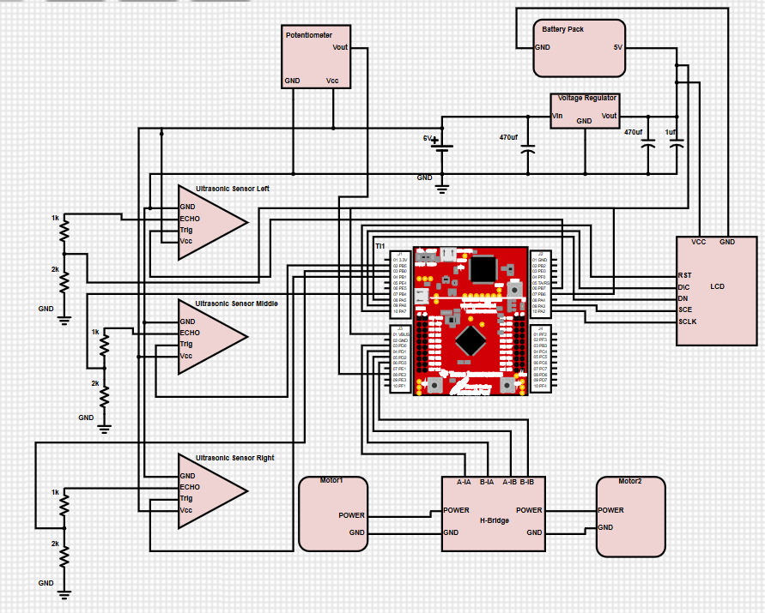

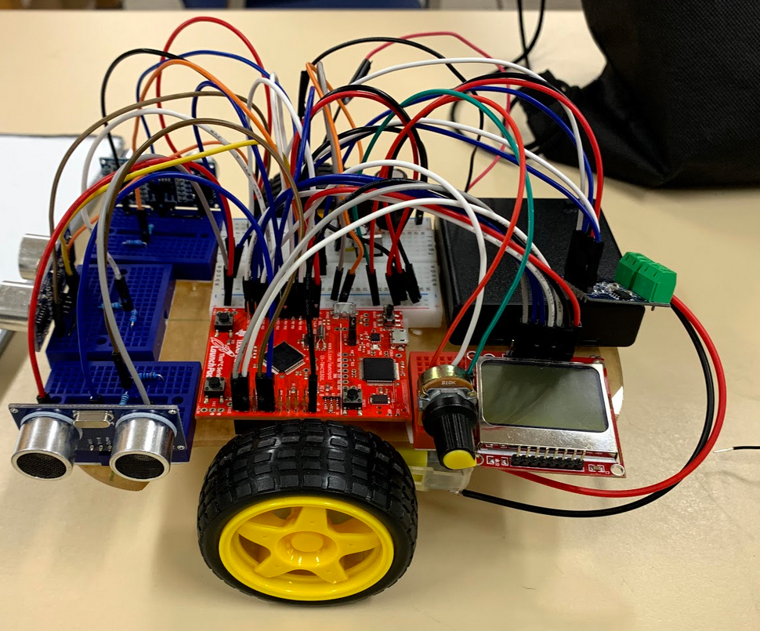

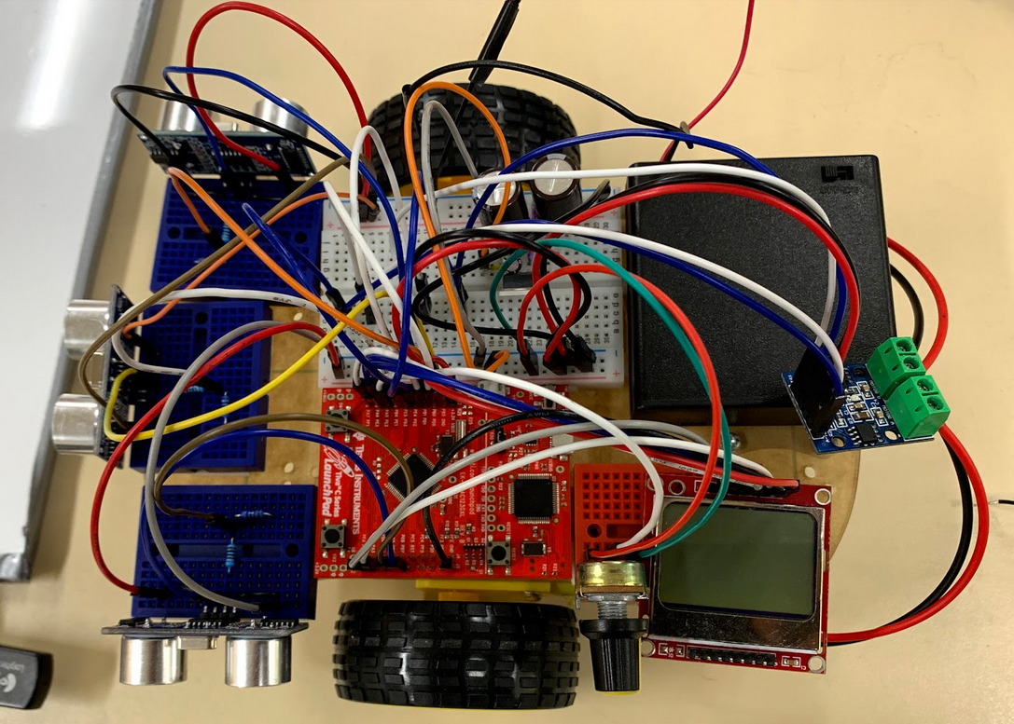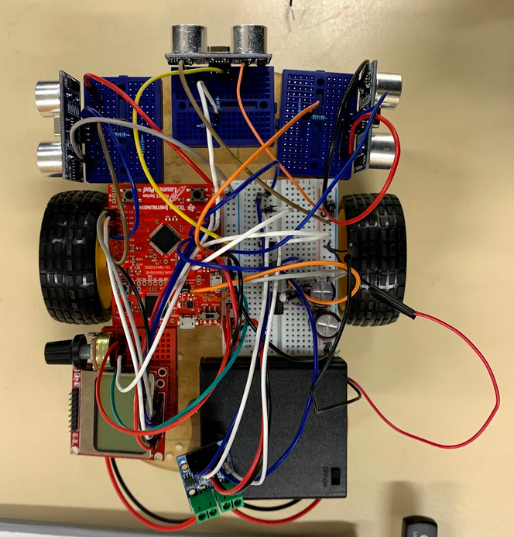

**Software design**

It is necessary to initialize all components on this autonomous robot car. Two files initialize the ultrasonic sensors and the motors. In the first file, ultrasonic.h, it initializes the three sensors implemented on the front end of the chassis. Each positioned in different locations facing left, forward, and right. For each sensor it has its own timer interrupt to capture the period between the rising edge and falling edge. This is used to calculate the distance that is detected by the ultrasonic sensor. Left sensor activates Timer0 with port PB6, and PB7 in place for echo and trigger. Front sensor follows the same layout implementation of Timer1 and PB4 and PB5. Third our right sensor enables Timer2 and utilizes PB0 and PB1. Finally the interrupts are enabled in the main program after all devices are initialized.

In another file, final.h, is intalization for the two motors and potentiometer. This is necessary for it is used to calculate the value to adjust the motion of the wheel. The max period (40 000) * distance is calculated for both the left and right sensor to convert the value to a float. The distance, L, will constantly fluctuate so we must account by using a float. Since the variable for distance is a long, a float is used and it is divided by the maximum distance. The motor goes to PD0, M1PWM0.

Attached is a video file for the test run, <https://drive.google.com/open?id=1Y-6C5VBOOz18vjiQ7zpijHQL9M2qzqod>. Also below are the screenshot of the files.

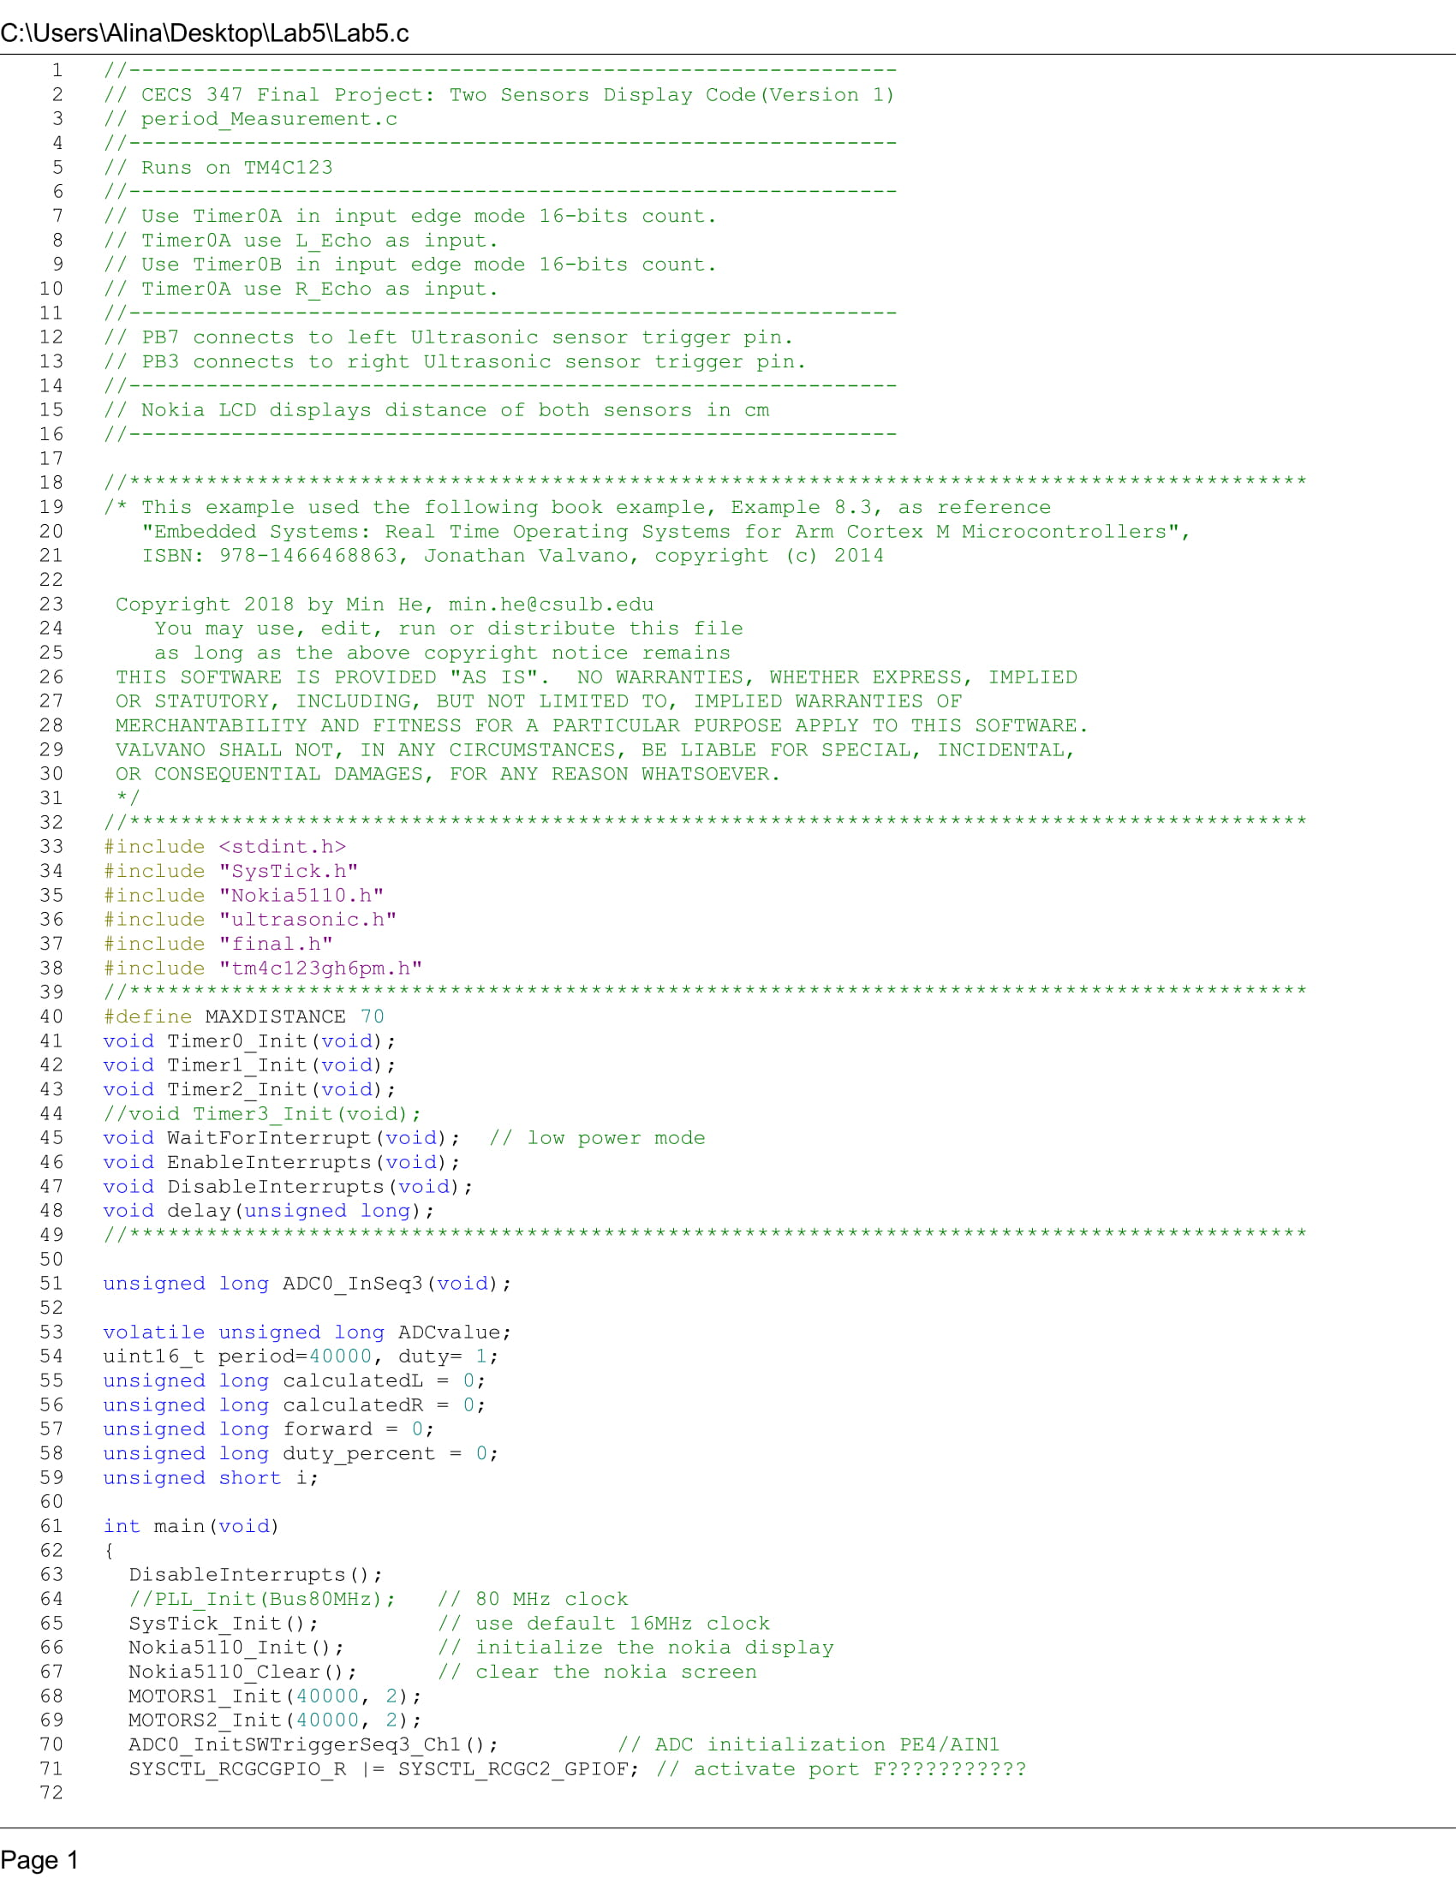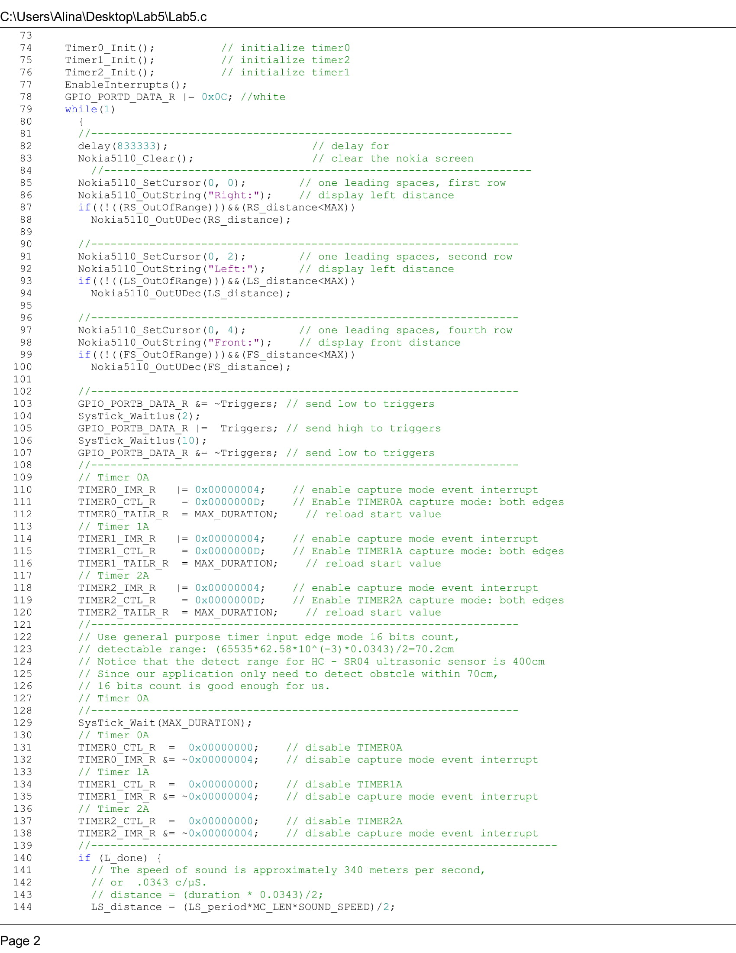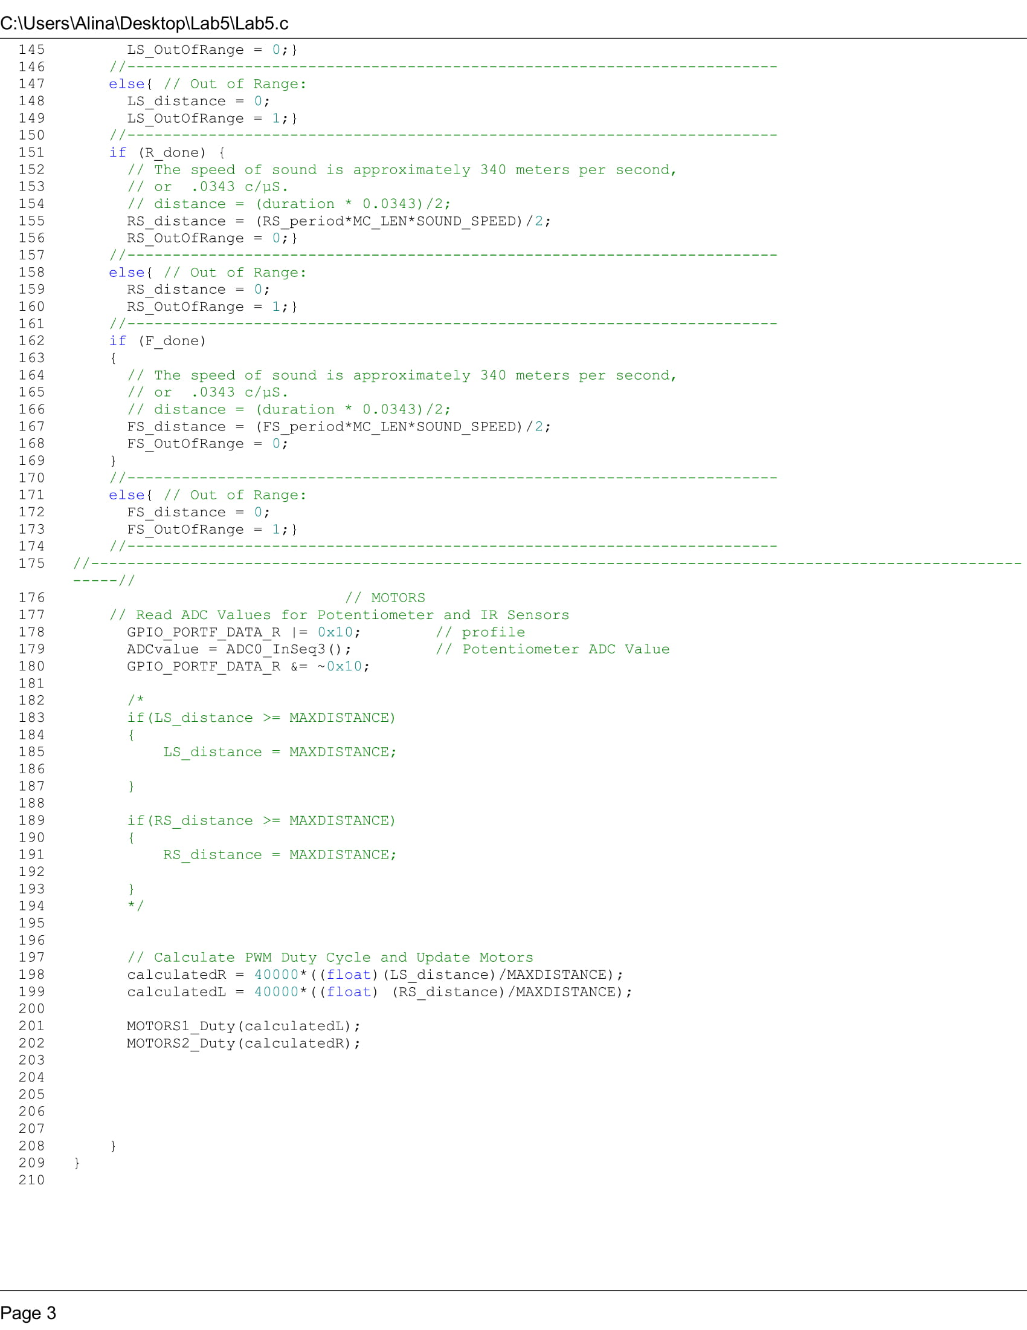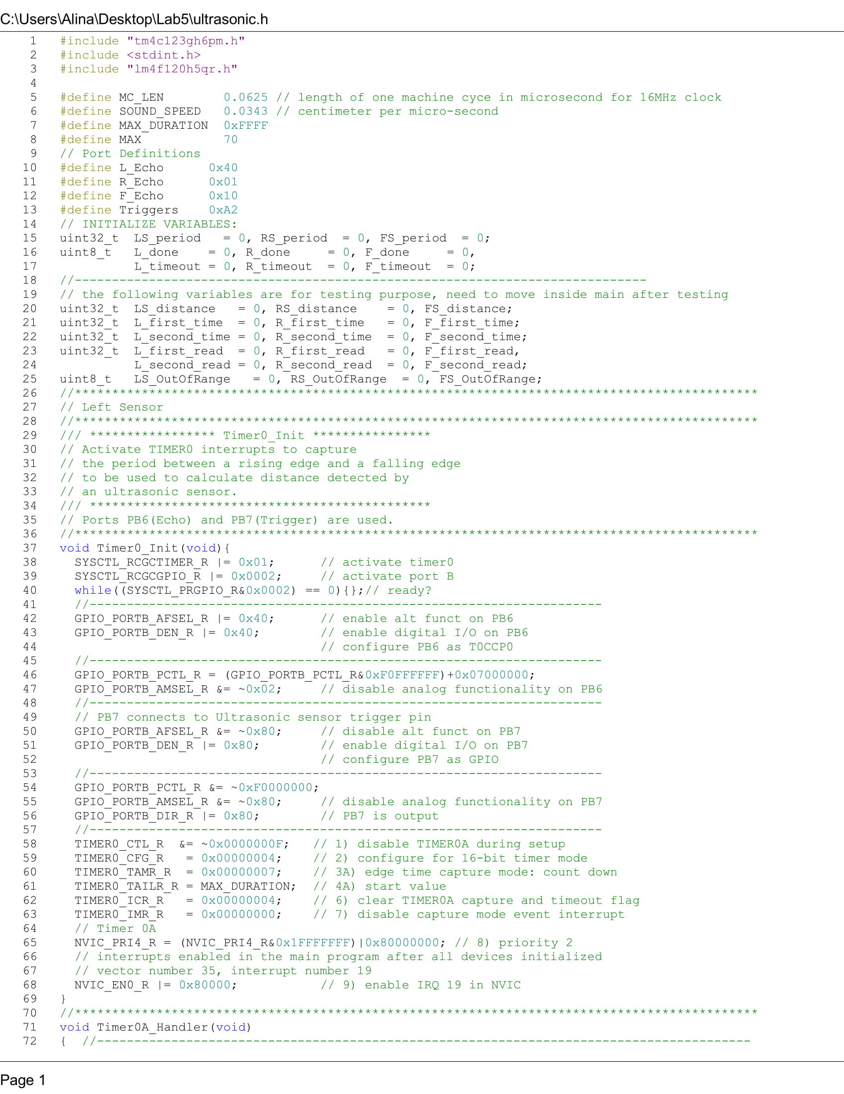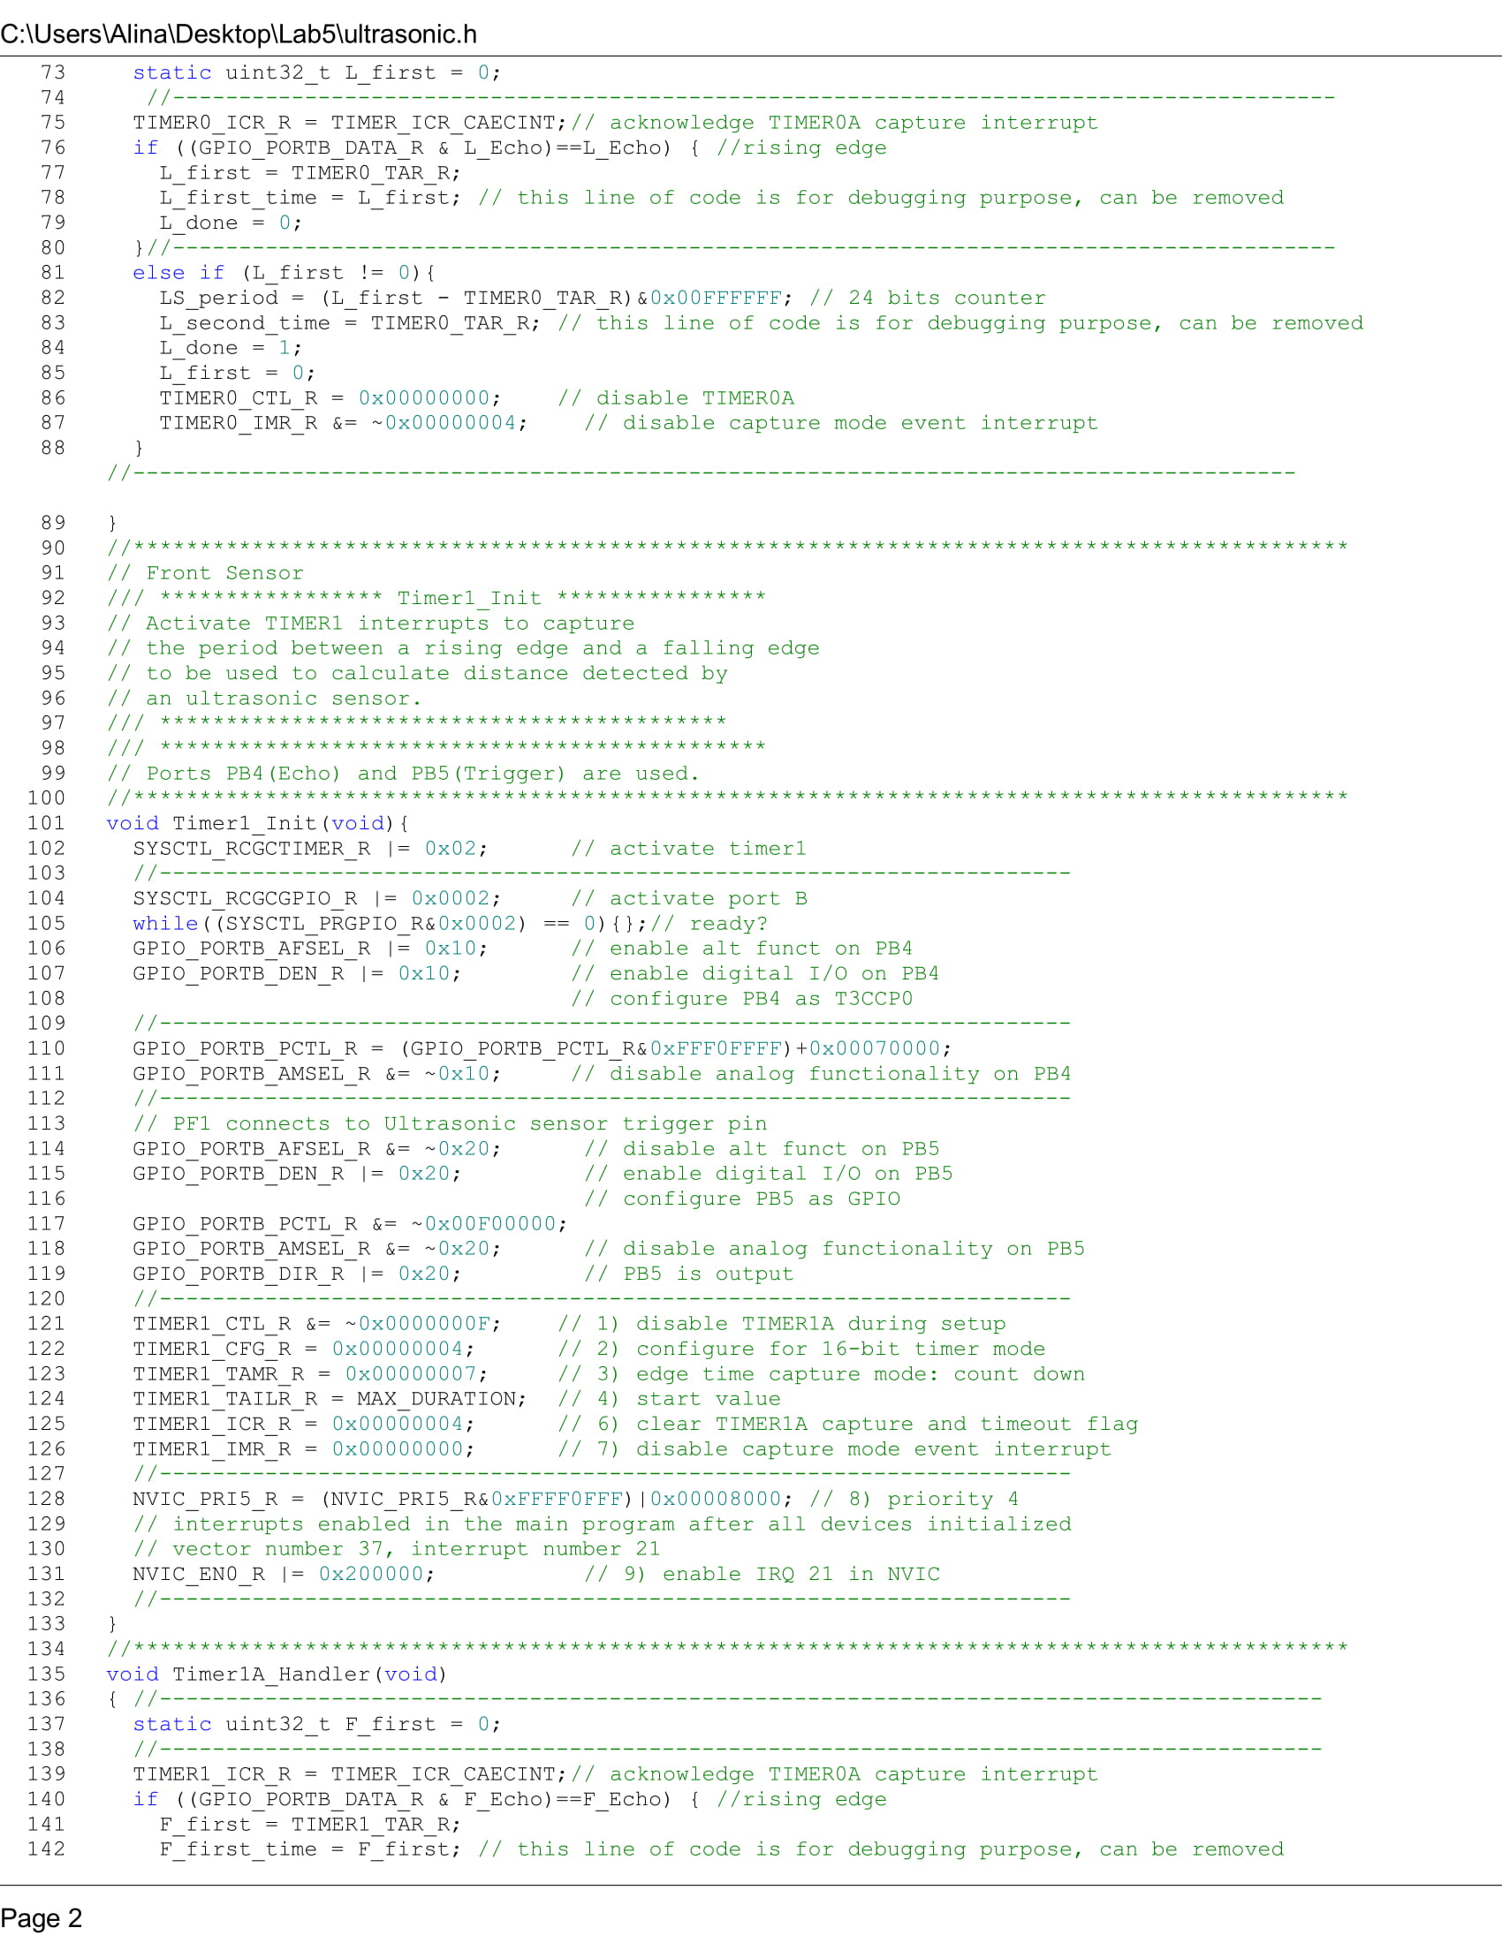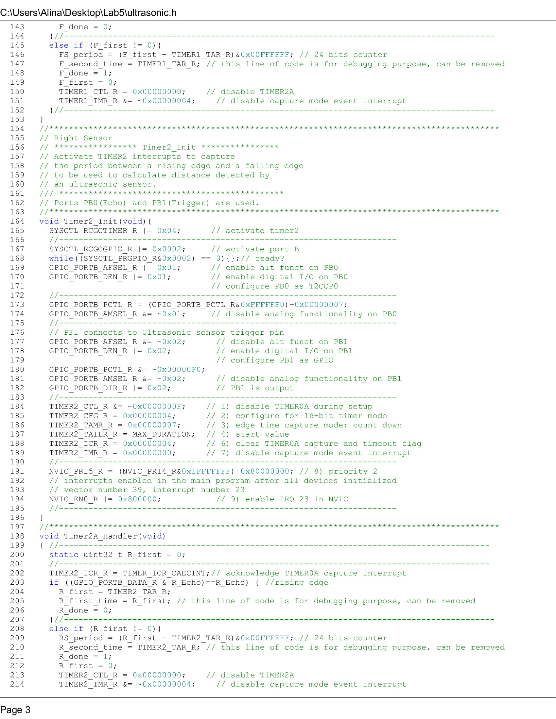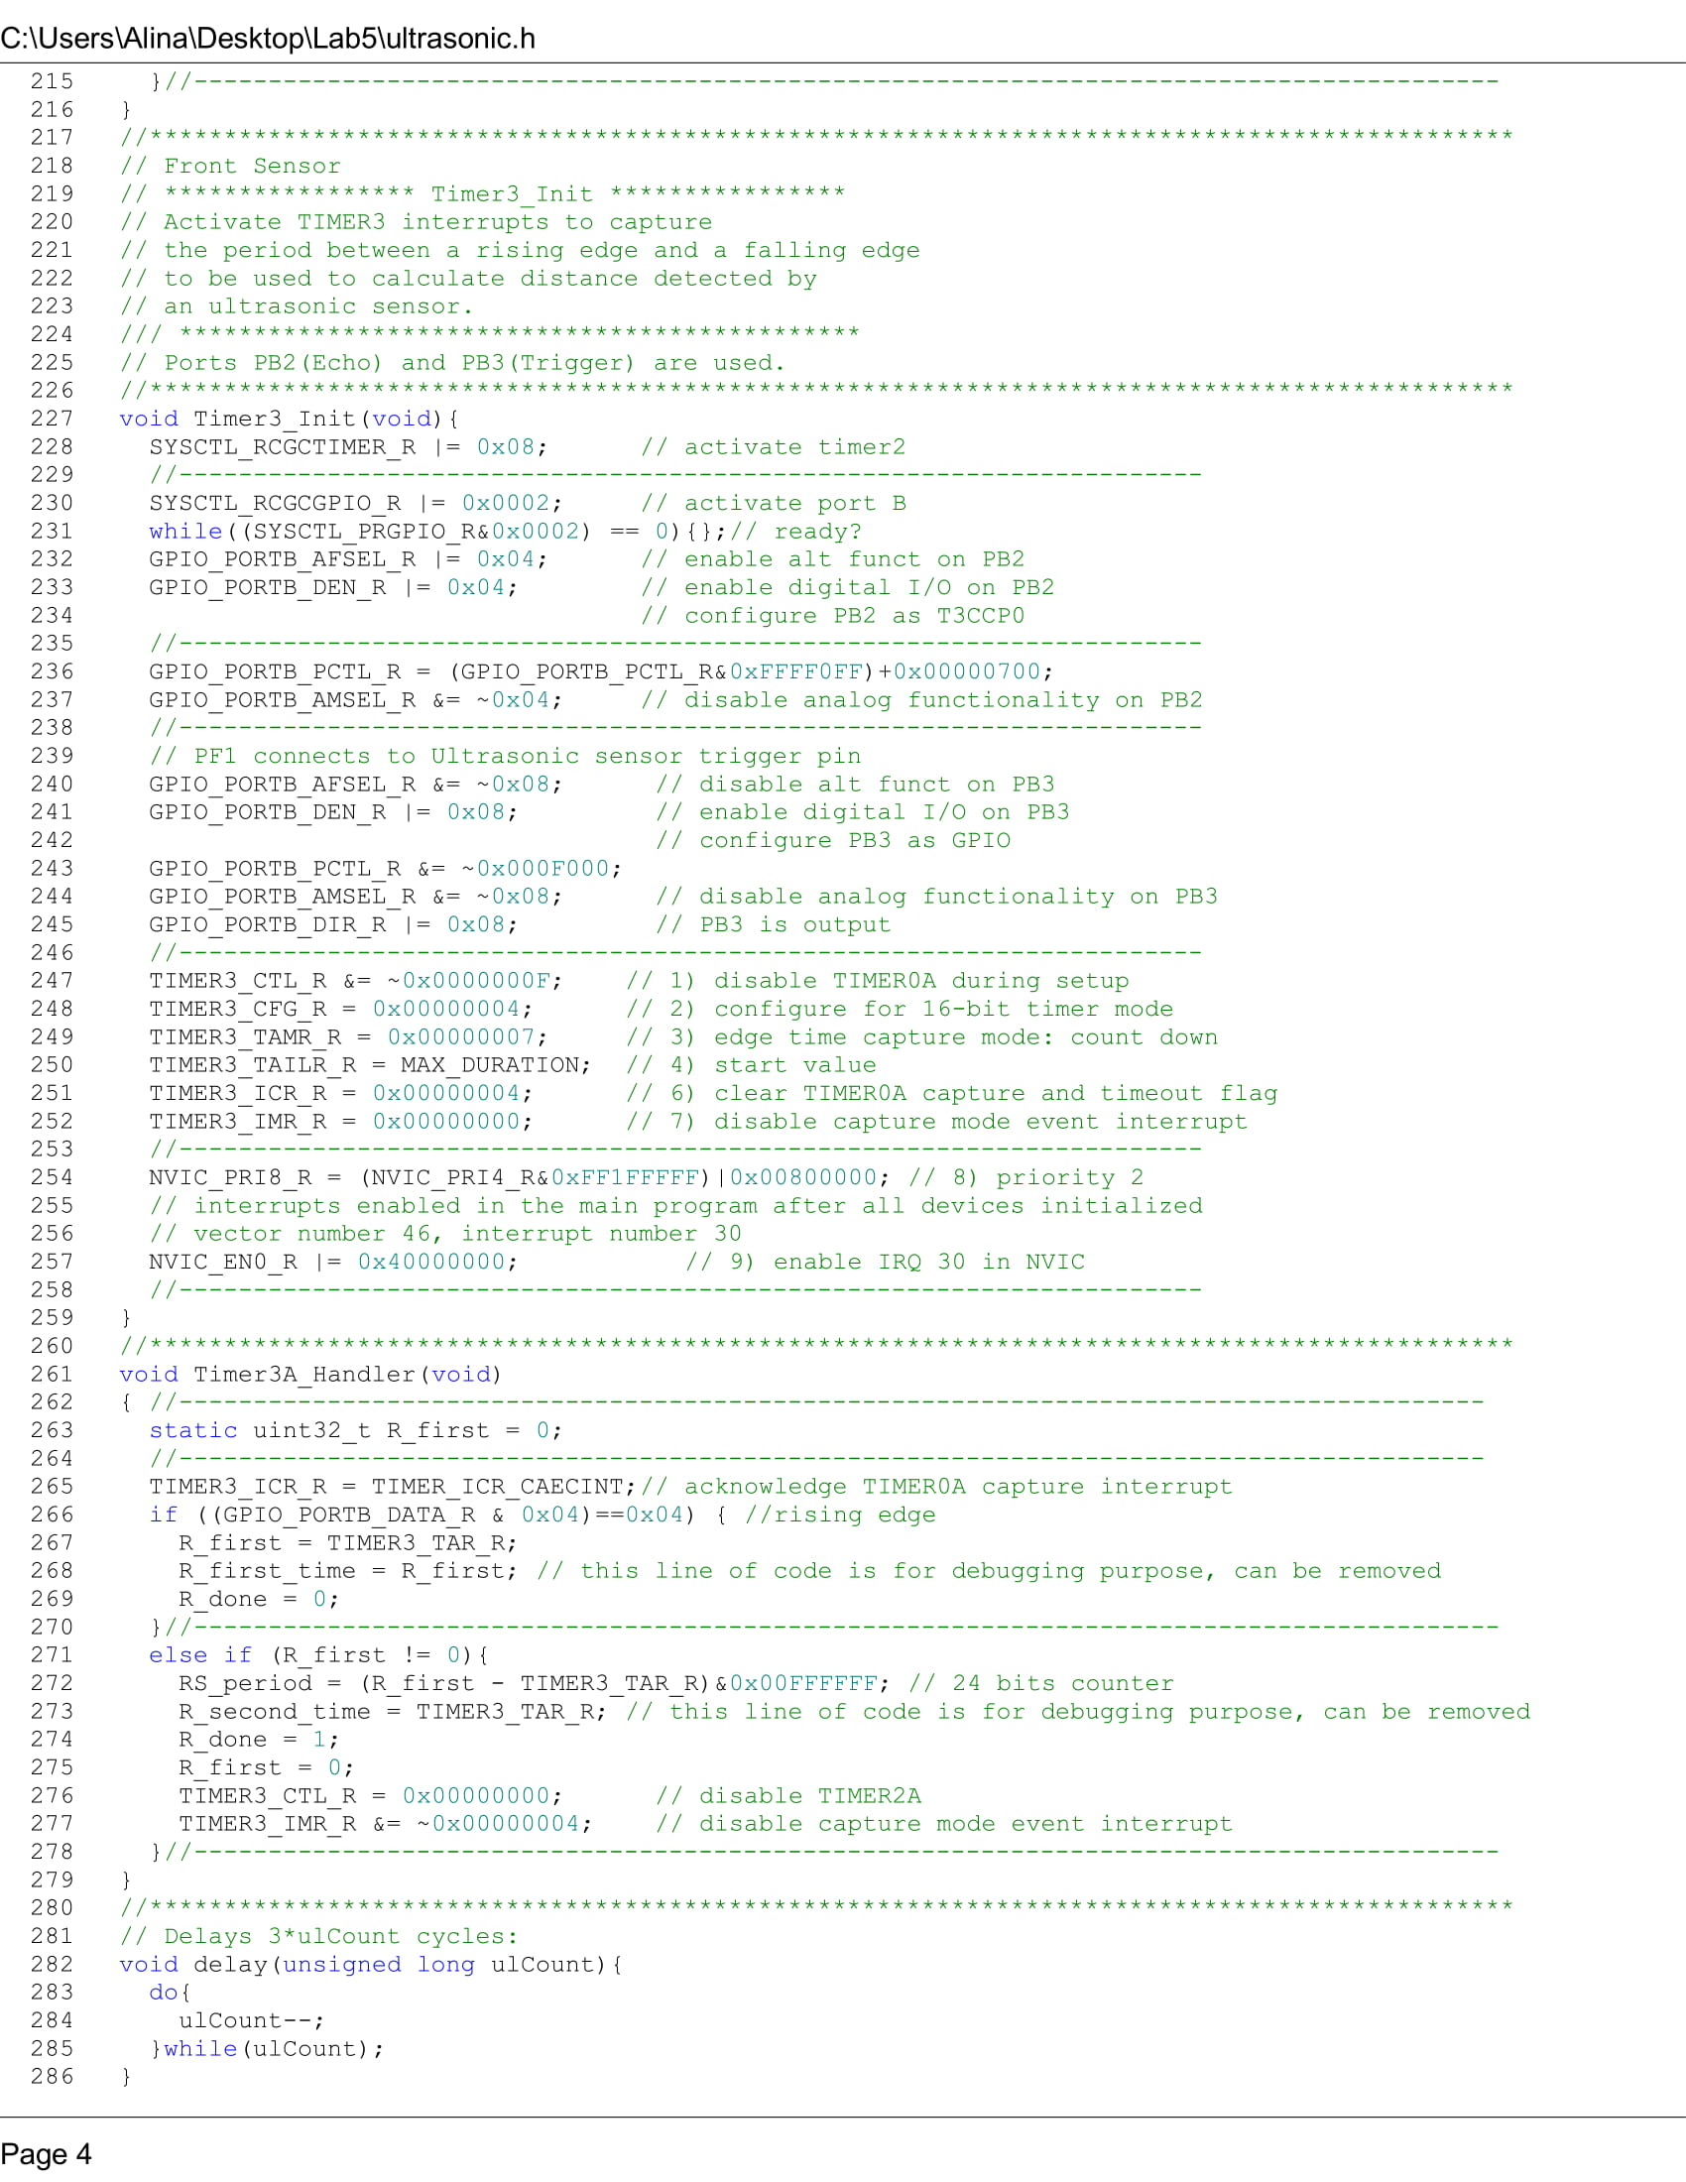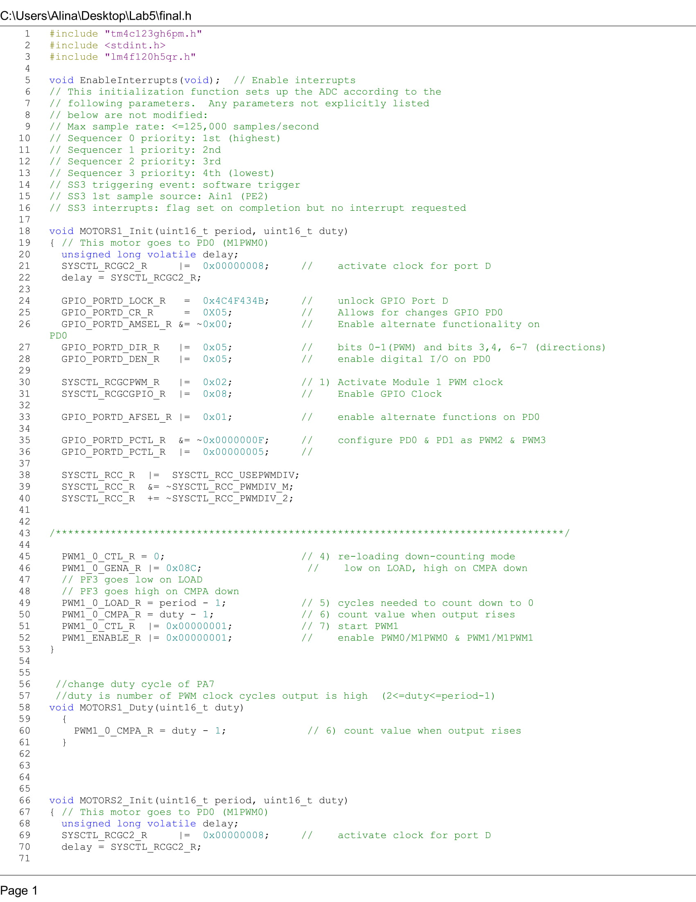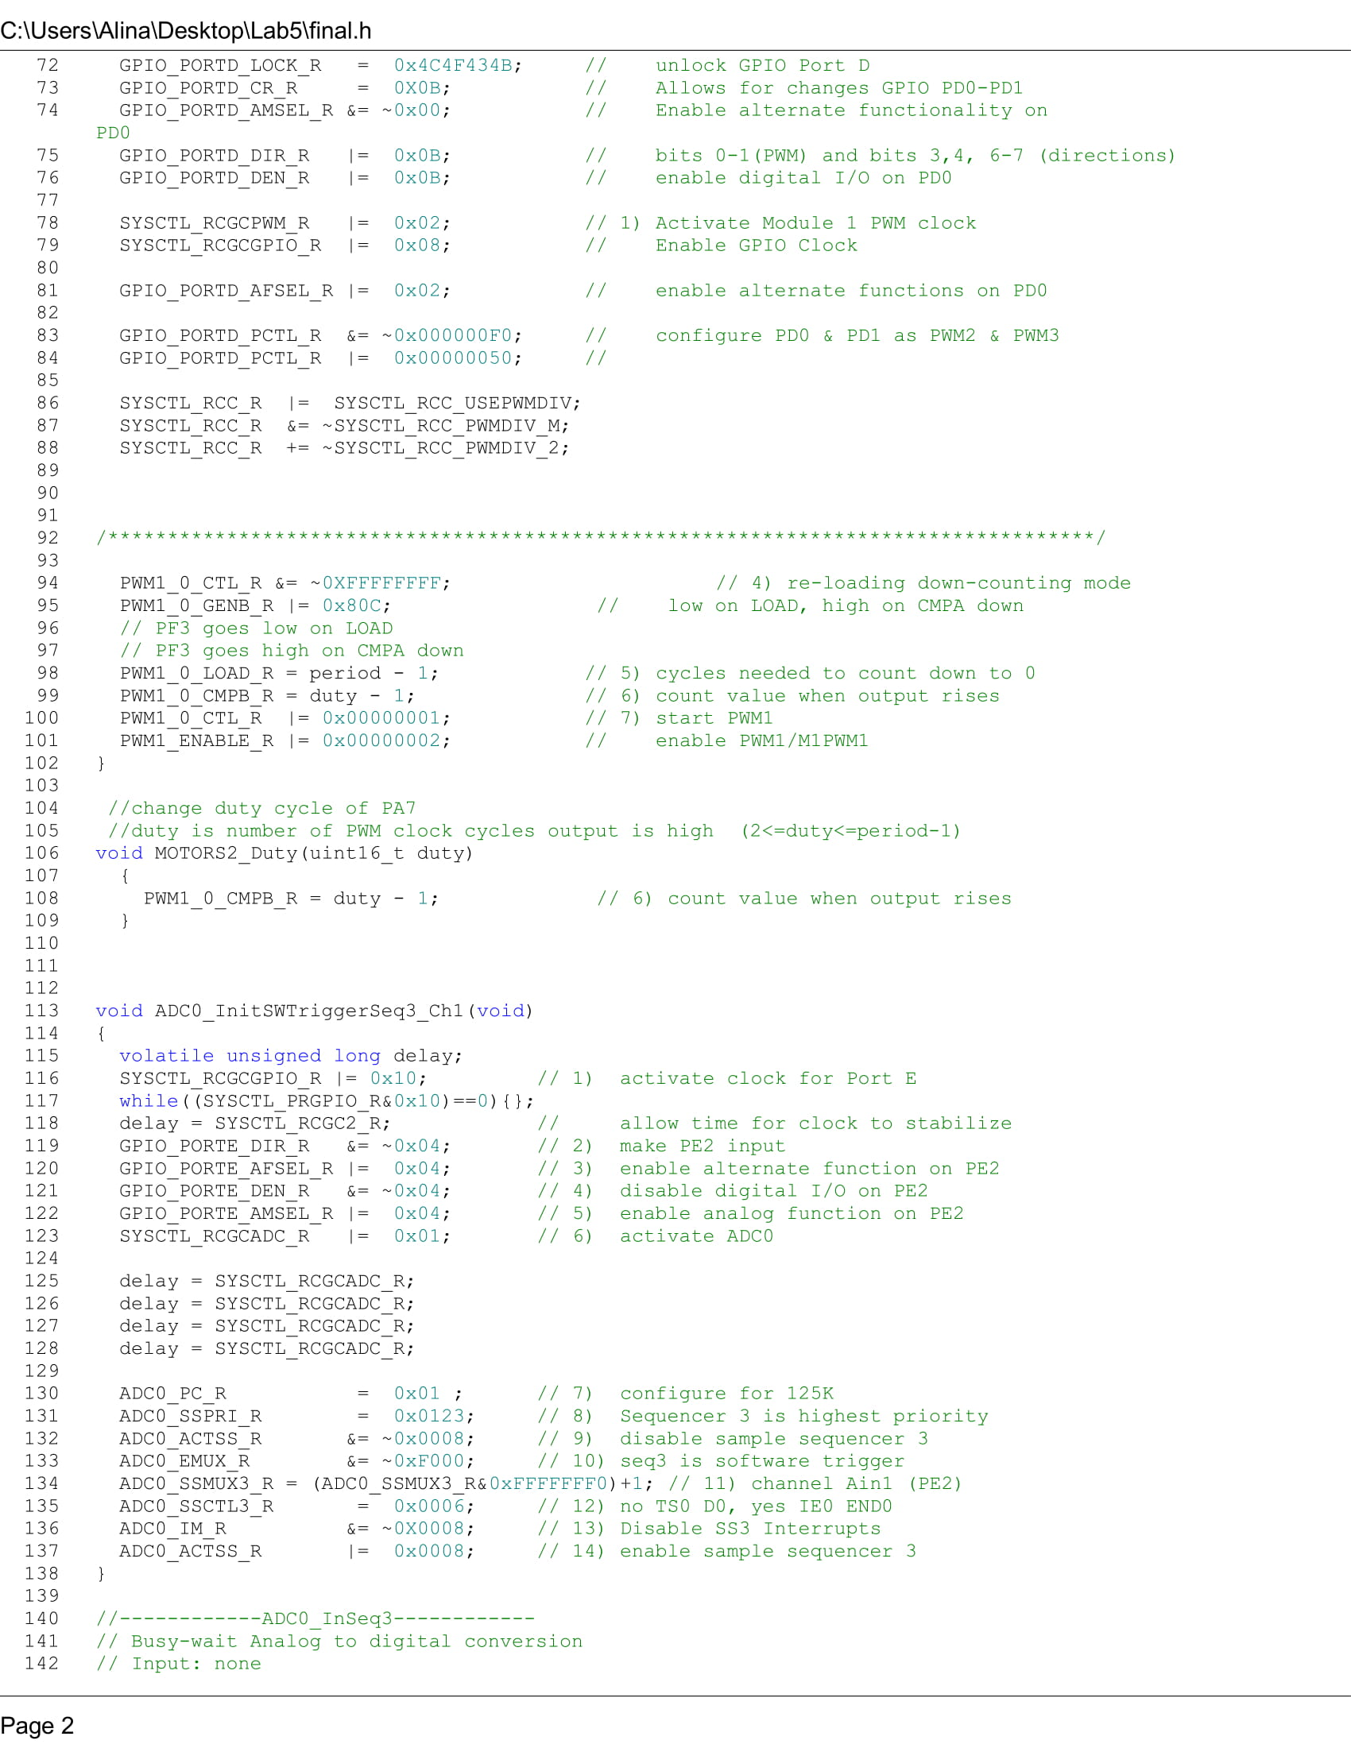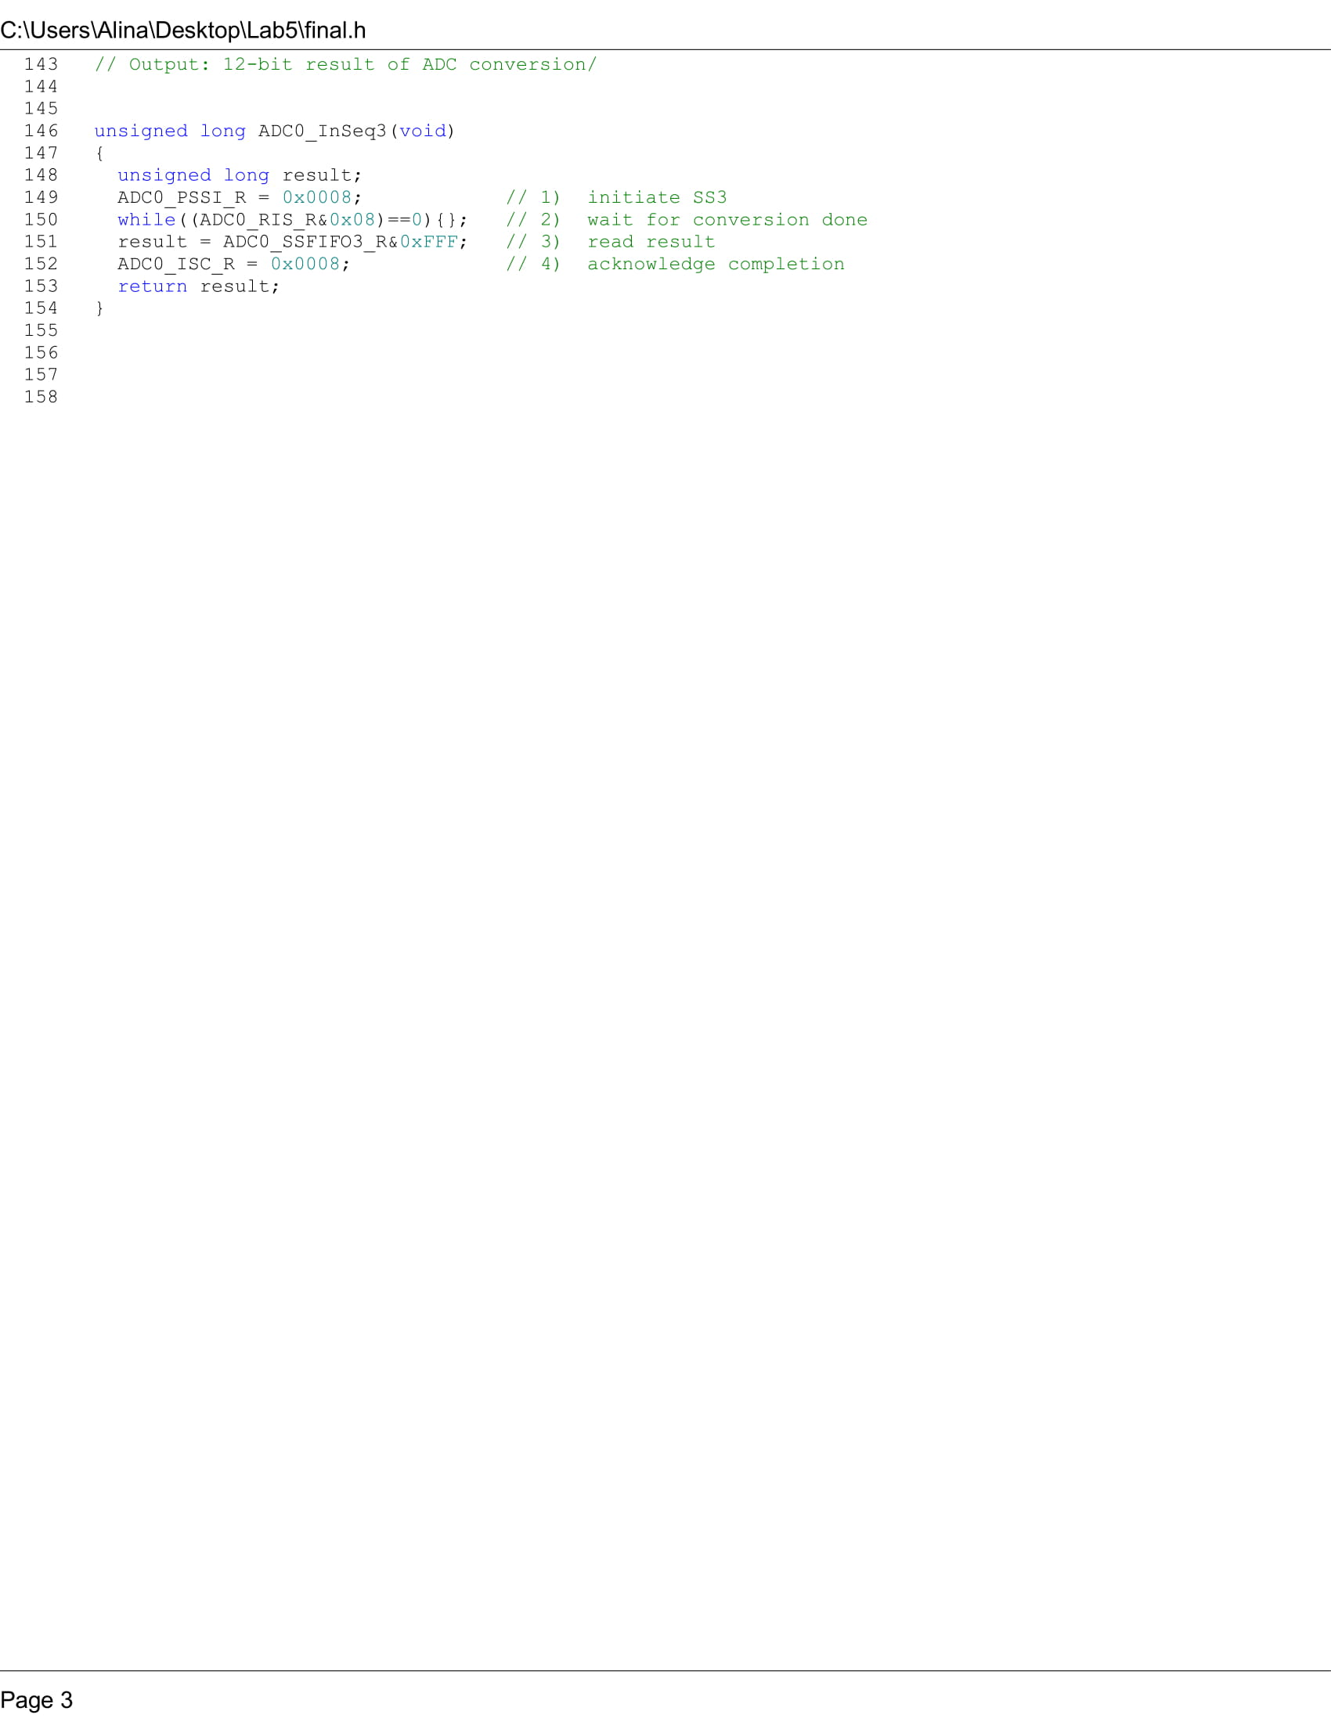

**Conclusion**

After persistent efforts we we’re able to devise an autonomous robot car. It navigates itself accordingly through two course track. In the first enclosed track, the car will move from one end to another in a straight line. The second course will add difficulty with both a left and right turn addition to the straightforward course. In the end of the course, the car is to stop motion completing its mission.

Through our efforts, we were able to overcome issues that occured in developing this autonomous car. The issue of initialization of an ultrasonic sensor created a major halt in our project. We were able to successfully initialize the left sensor, accurately reading the distance between obstruction. Port PB7 and PB6 are utilized for the left sensor. Though we were troubled in the initialization of the right sensor for the timer 1b and timer 2a.